**Application Deployment**

**Creating Action on GitHub:**

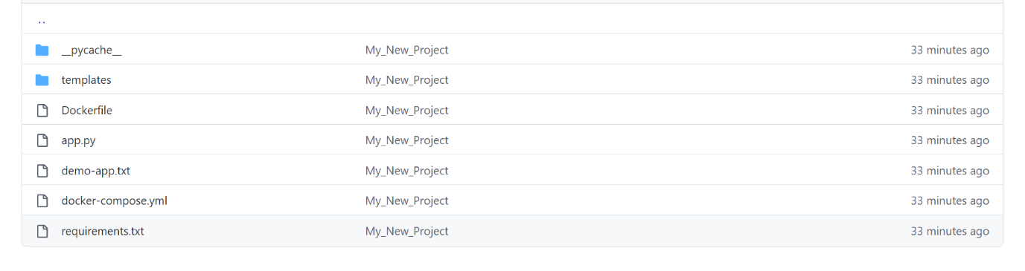

**Configure Openshift.yml for the application**

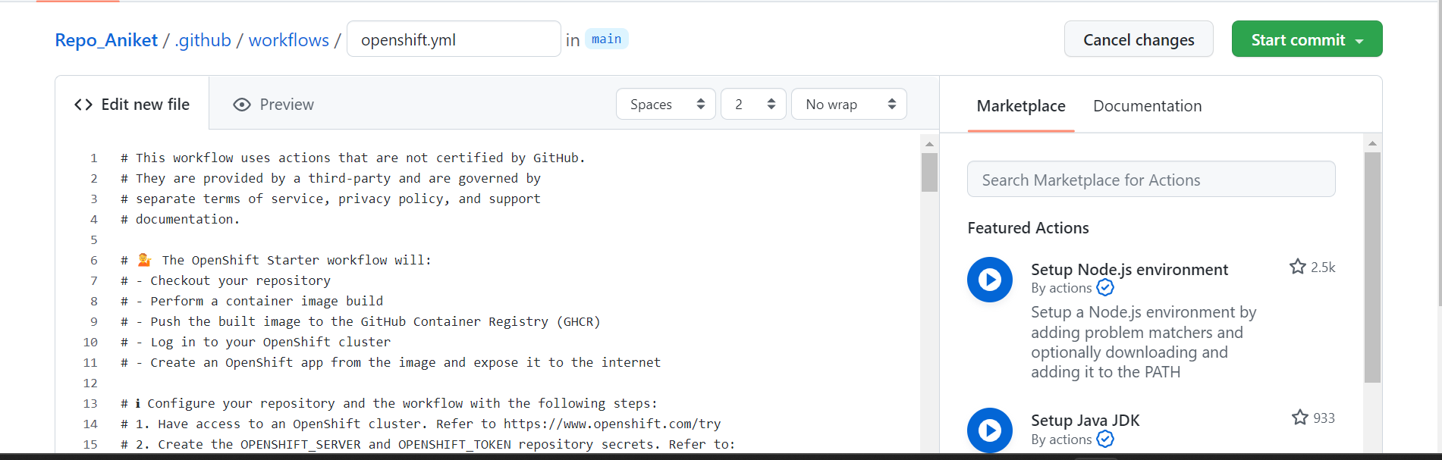

**Creating secrets for Repository:**

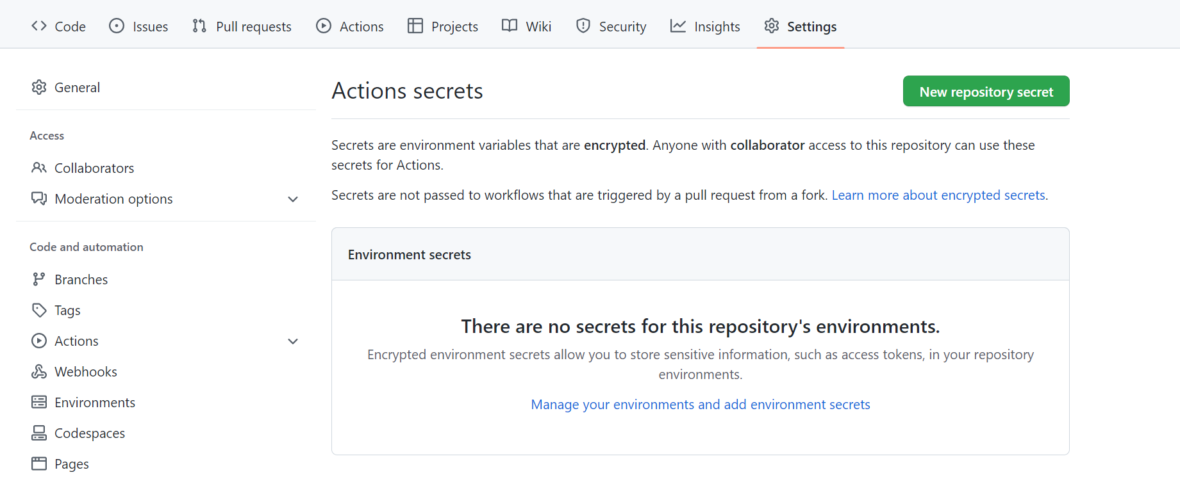

**Adding docker Hub path to Action:**

